Dashboard (Add Standard Chart)

Specification

# Product Brief & Goals

There are a number of preset charts that are universally useful and can provide a great starting point for our users. We want to create an easy way to add / remove these standard preset charts to the dashboard.

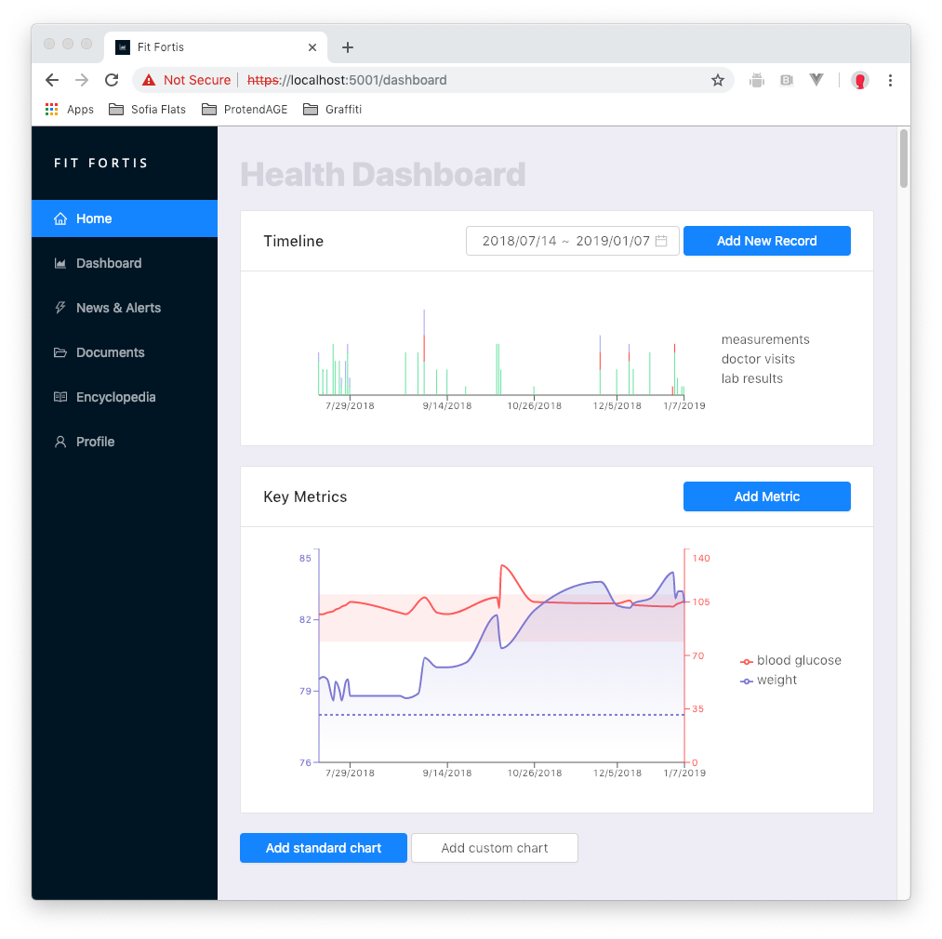

# Specific Requirements

1. When the user presses “Add standard chart” they should be presented with a UI that allows them to choose from a list of standard charts.
2. The charts would ideally show real data (if we have some) even in the choice dialog.
3. The user can remove and/or rearrange the position of the charts.
4. The standard charts come with their own unique formatting. For example, a chart that has to do with blood may utilize “reds”, etc.
5. Every metric also has unique capabilities. For example, a metric like weight will have a goal component, where the user can record a goal. A metric like “blood glucose” will have standard min-max levels calculated automatically given the user’s age, gender, conditions, etc.
6. Some metrics may be shown as lines, others as areas.